Computer Science 150 – 01
Spring 2014
Prof. C.W. Liew

Ivan Evtimov

Project 1

1. Set-up of the project
The project has been implemented in 9 class files and 5 test classes.
The general organization of the simulation is as follows:
The Person class provides the functionality for simulating the people who are in the building. Every Person gets assigned a time to arrive in the run of the simulation. Two classes, Tenant and Visitor, are inherited from the Person class and take up all of its functionality. On each simulation run, the ratio of tenants to visitors is 3 to 1.
The Floor class holds the Person objects at the beginning of the simulation. It also provides the implementation that simulates the normal distribution of the times to arrive of the people. It uses an ArrayList container because quick random access by index is required.
The WaitingLine class simulates the waiting lines that pile up in the waiting area for entry to the staircases when the fire alaram goes off. Since not everybody can enter the staircase right away, people wait in the waiting line until there is an opening in the staircase. The WaitingLine class is an implementation of a queue and has been adapted from a previous lab assignment.
The Staircase class provides the functionality needed for moving the people objects outside of the building. It resembles a queue with multiple entry points in its implementation since people can only enter at their floor and can only exit at the bottom of the staircase. Again, quick random access by index and more importantly, constant size is needed, so an ArrayList is used in this class's implementation.
The Building class holds the containers for the multiple instances of the Staircase, the Floor, and the WaitingLine classes. Data is accessed through an iterator for the purposes of object-oriented data hiding, but the underlying data structure is an ArrayList once again for similar reasons as for the other classes.
The Simulation class ties everything together and runs the simulation providing information on time steps needed for completion. In the final version that has been submitted, it reads data from a param.txt file and uses it to start the simulation. However, for conducting the experiment, the class was temporarily modified to perform the simulation with different seeds and varying numbers of floors, etc., as per assignment.
For more details on the implementation, please consult the appropriate JavaDoc.

2. Varying number of floors with a fixed amount of staircases

For this experiment, I construct the building so that its staircases always have a capacity of 10. The number of tenants per floor is normally distributed and has a mean of 50 and a deviation of 10. The time to arrive for each tenant at each floor has also been normally distributed and has a mean of 30 and a standard deviation of 10. These variables are held constant for the purposes of this experiment.
The goal is to establish a pattern when we hold the number of staircases constant and vary the number of floors. Hence, I fixed the number of staircases at 1, 2, 3, 4, 5, 6, 7, 8, 9, 10, 25, 50, 100, 150, 163. At each number of staircases I run the simulation with 1, 2, 3, 4, 5, 6, 7, 8, 9, 10, 25, 50, 100, 150, and 163 floors. The number 163 was chosen as upper bound because that's the number of floors of the currently tallest building in the world.
Out of all the generated data, I choose to consider the situation with fixed staircases numbering 1, 10, 100, 150. Since each simulation run was performed with 6 different seeds, I look at the average of all of them.
The results can be found in these tables:

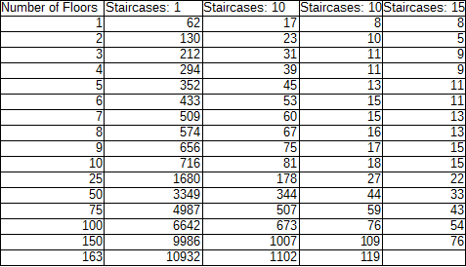
Table 1: Average number of steps taken to complete evacuation of building with varying number of floors.

The data is also plotted here:

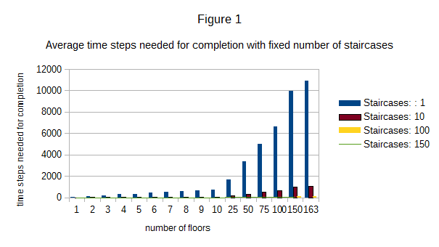

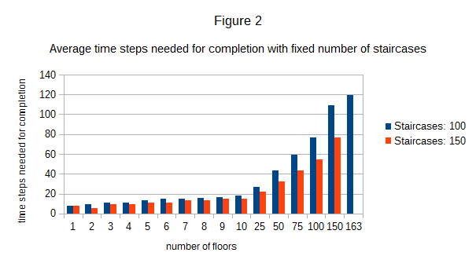

It is evident, especially from Figure 2, that as the number of floors grows, so does the time required to evacuate the building with a fixed amount of staircases. This corresponds to the situation in the real world. For a faster evacuation, you will need more staircases.

3. Fixed required time for evacuation

The experiment is set up, so that the simulation doesn't complete until a satisfactory number of staircases (that evacuates the building under the given amount of time) has been found. Based on the output, I could see that no matter how many times the simulation was run with different seeds, the number of staircases was all the same. The fixed timestep limit chosen was 300 time steps. The same other variabales are held constant as in 2.

The data is given in the following table:
Table 2: Number of staircases needed for evacuation within 300 timesteps
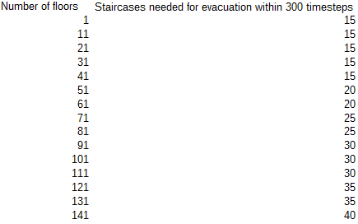

It is evident from this table that the number of staircases needed for evacuation within a preset time grows as the number of floors grows. However, it does not grow as fast as the timesteps needed for evacuation of a building as the number of floors grows with a fixed number of staircases. Again, this situation is analogous to the real world.

